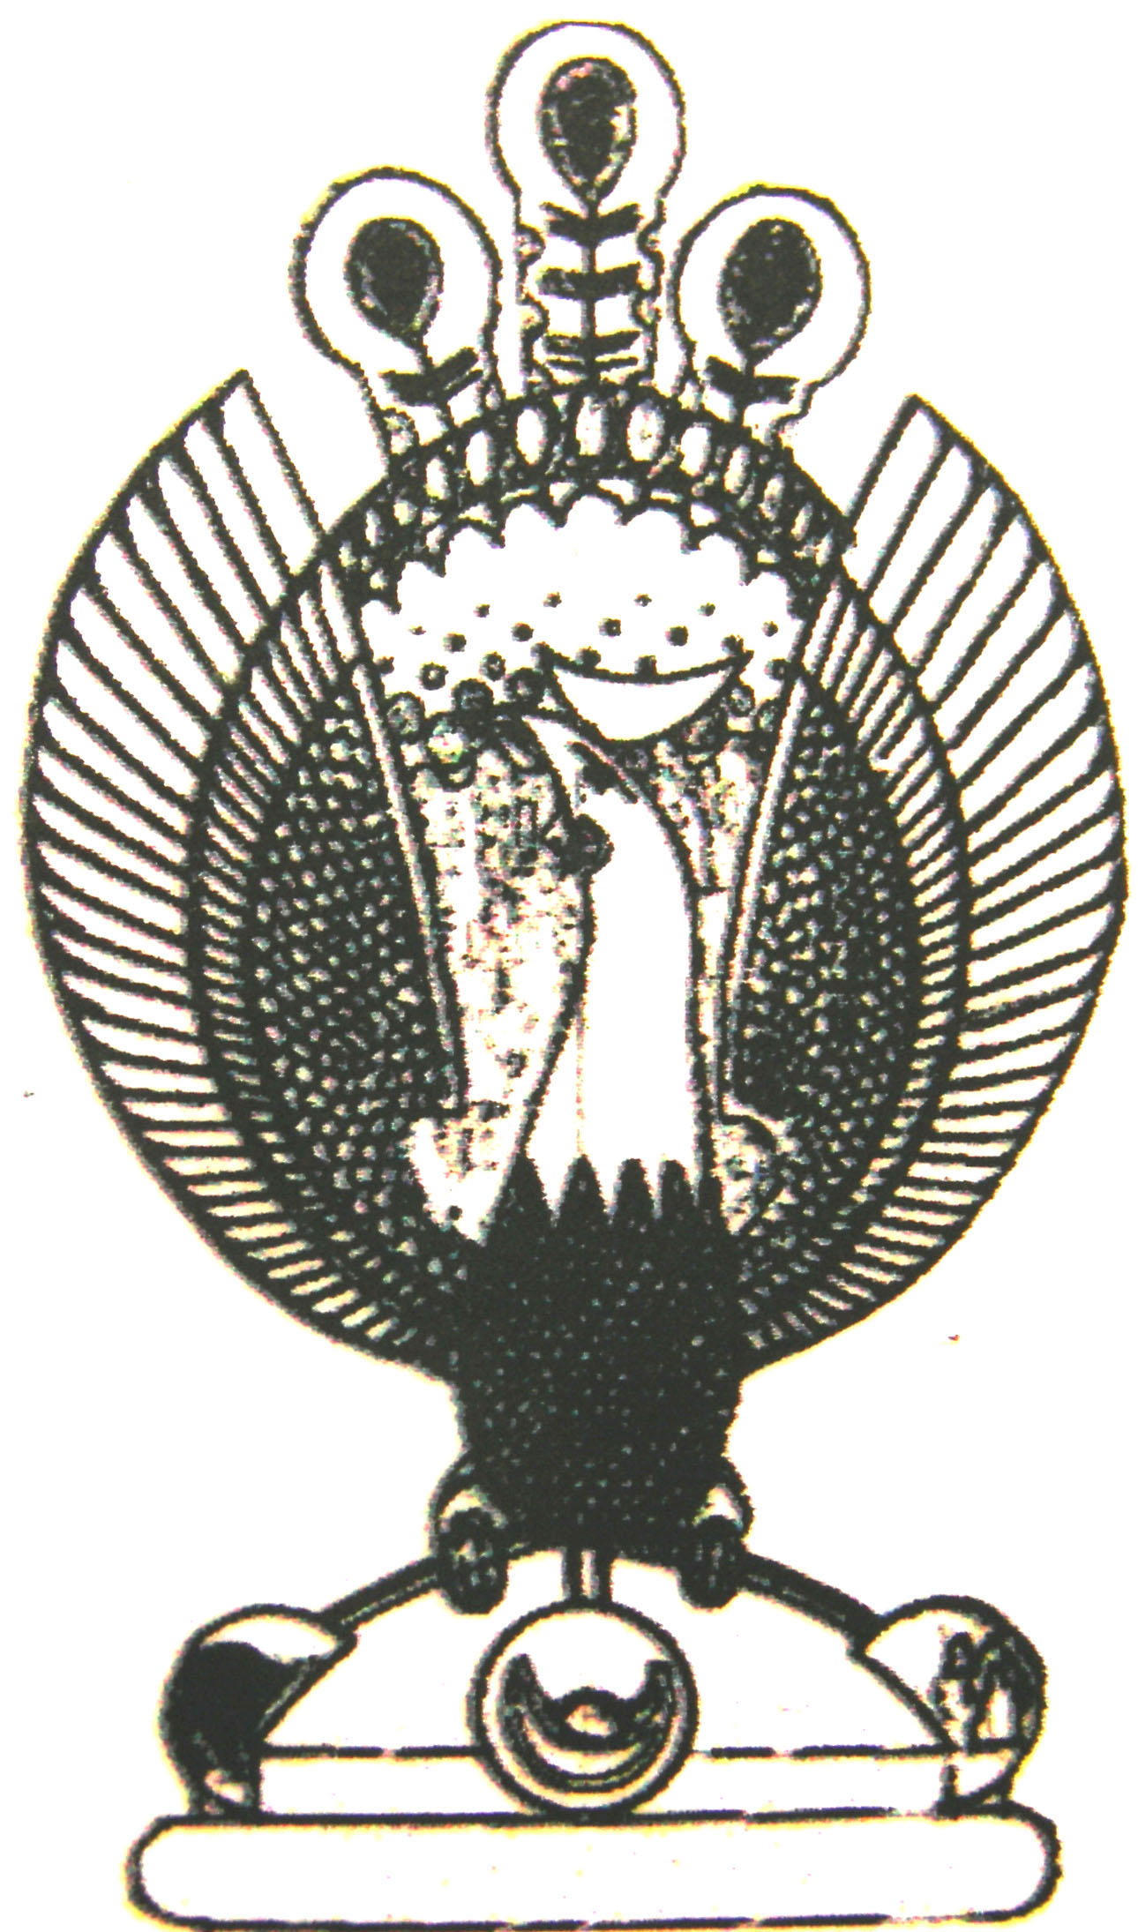

THE HERITAGE

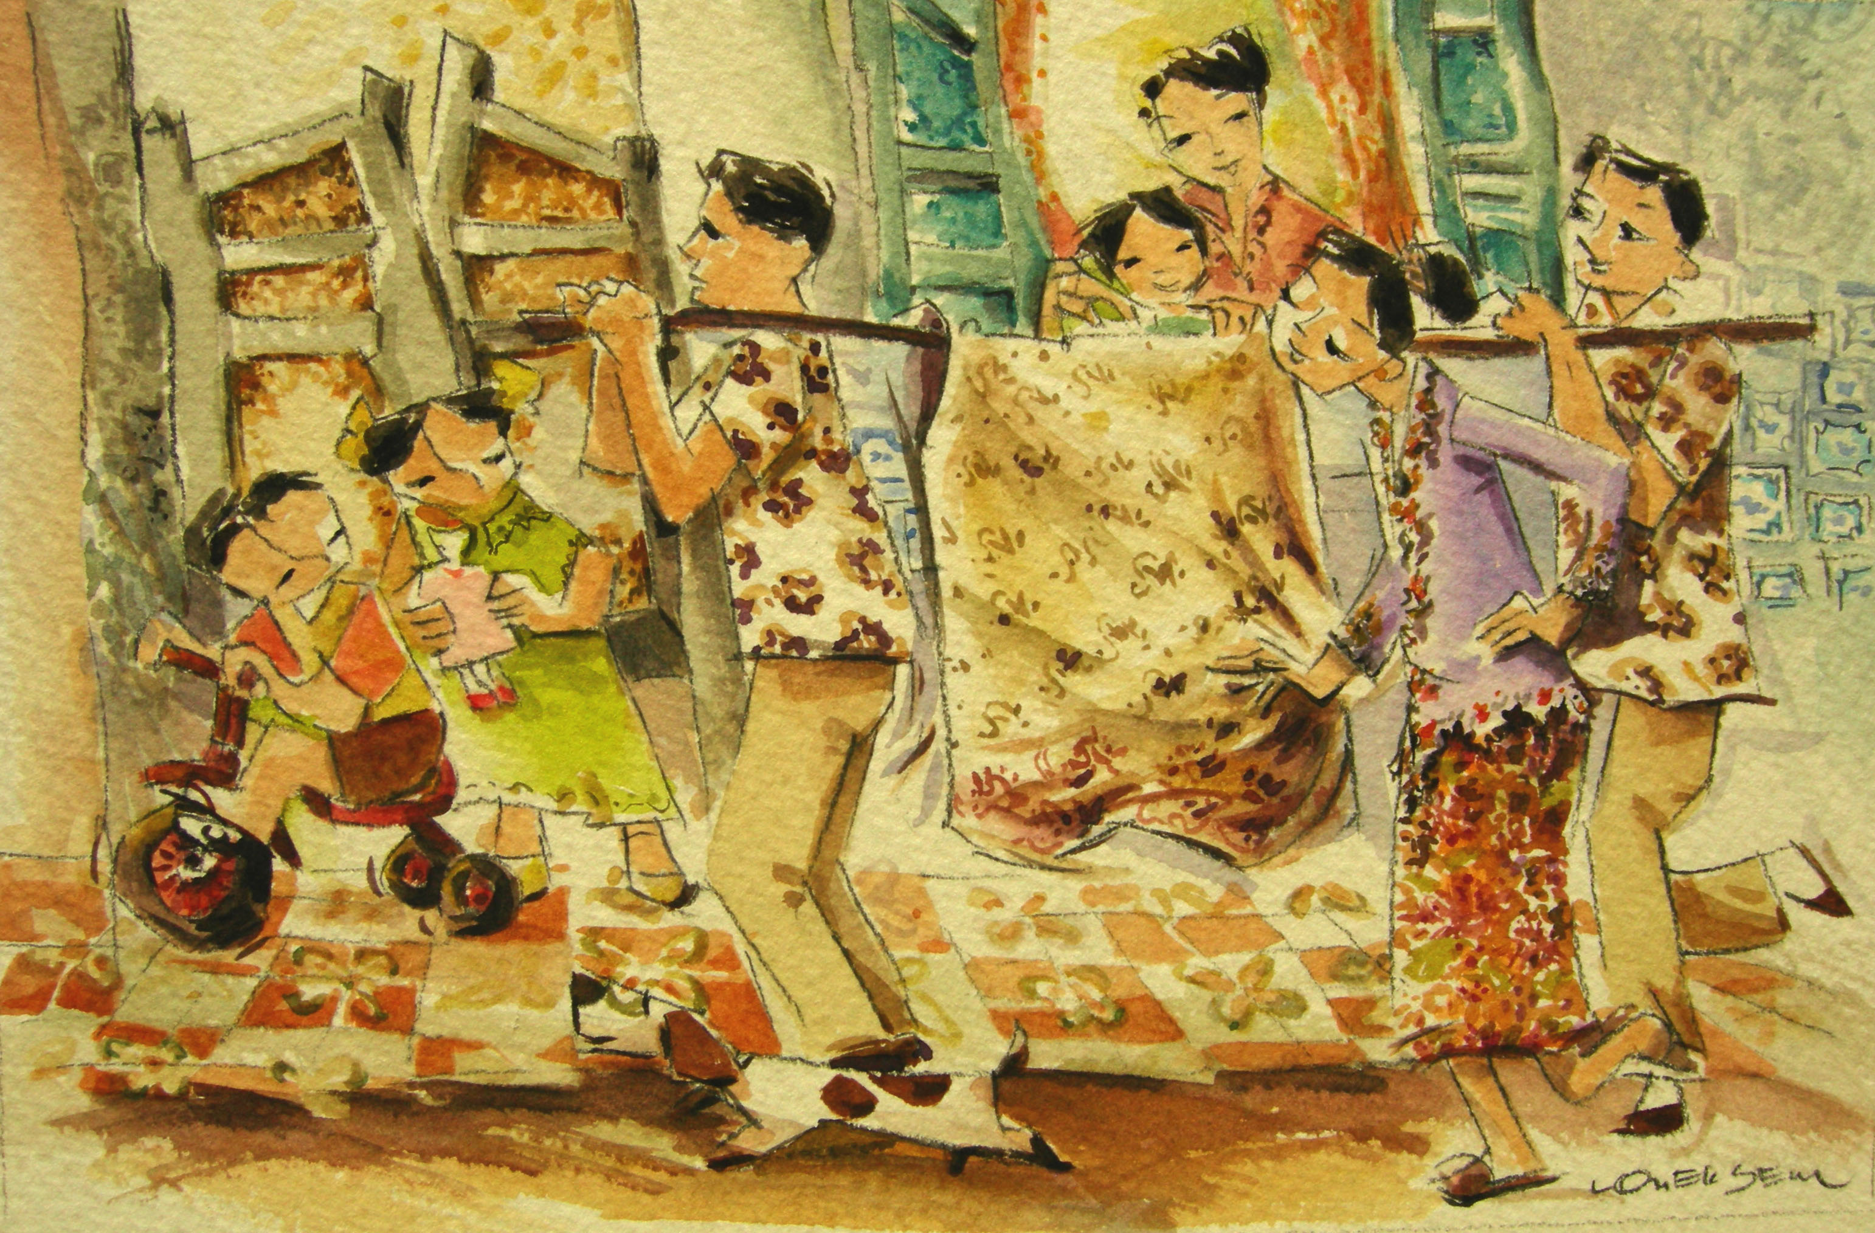
Redi
‘Redi (modesty board) Unmarried girls who venture outdoors must be shielded from public view except on Chap Goh Meh.

